Apps Instructions

ThingLink (Make your images come alive with private video, notes, or even music from YouTube)

How to use it:

1 - Signup (https://www.thinglink.com/) creating an account. Do not forget to register as teacher because this option allow you to manage classes inside ThingLink.

2 - You can access yours “thinglinks images” via web (https://www.thinglink.com/) but the best way to create the “thinglinks images” in outdoor activities is by using a mobile device (smartphone or tablet).

3 - As you already have this app installed: first login.

After it just start by creating a new “thinglink image”. Click on the + on the right top corner.

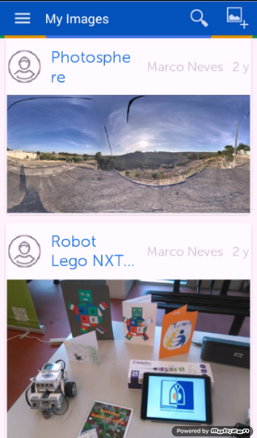

4 - First step is to choose an image that will be the background of the “thinglink image”.

You can either use an image already saved in your device or take a photo with your device.

5- Any were during the track choose an amazing landscape, a tree or any other place and take a photo. Could also take a photo with your team members.

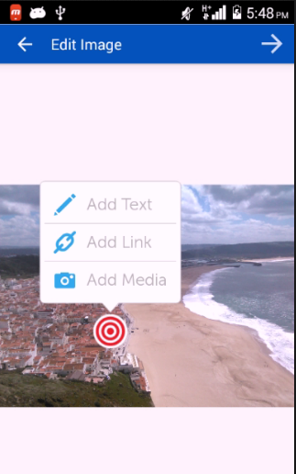

6- After that just add multimedia tags in your background image that could be text, another image or even vídeo.

Just click anywhere on the background image.

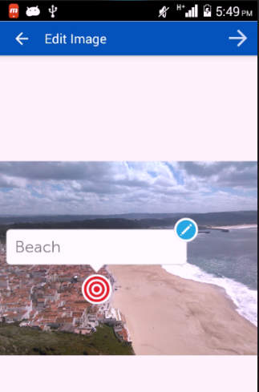
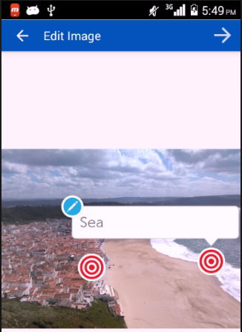

An example of a text point.

Add as many points as you wish.

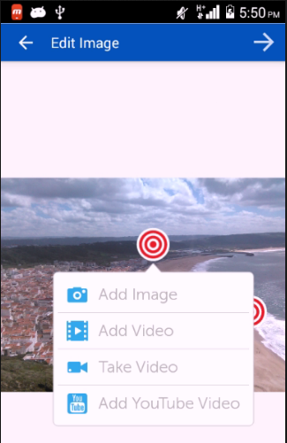

The “Add Media” possibilities (image, video…..).

7- When you finish add all the points you need to save the “thinglink image”. Just click on the right arrow on the right top corner.

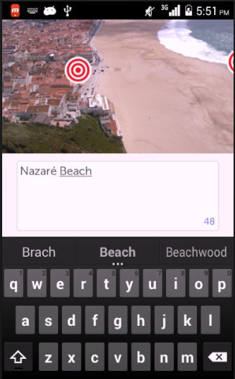

Give a name to your “thinglink image”. An that´s all. You just create a “thinglink image”.

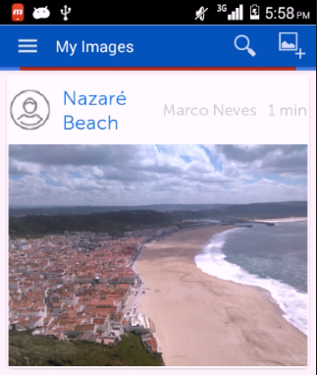

Now you can see the last “thinglink image” on yours “thinglink image” list.

After it you can share it so others can see it and explore it.

Just click on the “thinglink image” to open the share options.

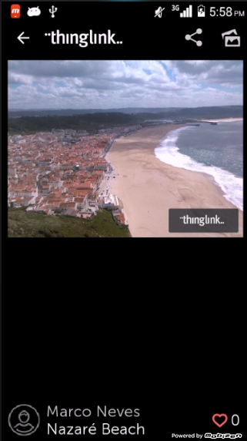

8- Click on the share button and share your “thinglink image” via Facebook, Twitter. etc..

Do not forget to share with us your “thinglink images”.

On Twitter use the seminar hashtag: #etwoutdoorsibenik

Explore an example of a outdoor activity created during a PDW in Guimarães - Portugal:

https://www.thinglink.com/scene/587705703582400516

Mapinr (An App to view and add points of interest in a Map and to georeference a path with pictures that can be seen and explored in Google Earth)

Download Android (only available for this type of devices)
https://play.google.com/store/apps/details?id=at.xylem.mapin

The main goal of this app is to record a track (by geo referencing it) and at the same time add/mark POIs (Point of Interest).

Imagine that you take your students in a field trip and along the way there are points that you consider relevant to study/observe.
Using this App you and your students are able to record the track, that you are following, and at the same time when reach a point of interested add/mark it by adding text information or even photos.

During the track you could collect more information by using the device or even a pencil and piece of paper. Because after finishing the track you are able to export it and explore it in Google Earth.

Once in Google Earth you have the opportunity to use all the information provided by Google Earth and contextualize the track and enhance the POI (points) by adding more information that you collected.

How to use it:

The App have a right and left menu: to access it just slide your finger on to right or to the left.
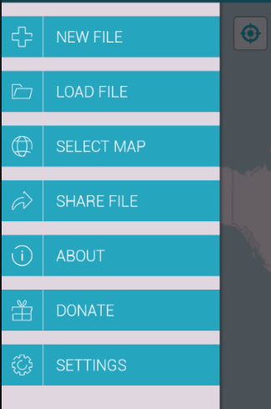

The “Right Menu” has the main functionalities of the App

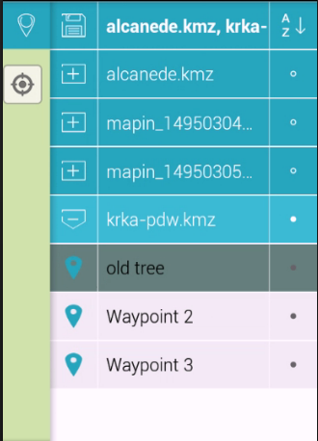

The “Left Menu” has the options to manage the different tracks and the points.

In the example the track krka_pdw.kmz has 3 points:
- old tree
- Waypoint 2
- Waypont 3

1- To start a new track just open the “Right Menu”

2 - Choose “New File” and name it.

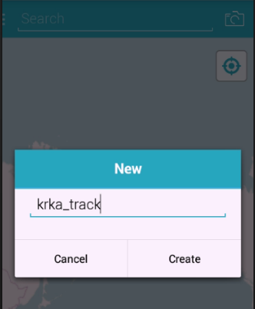

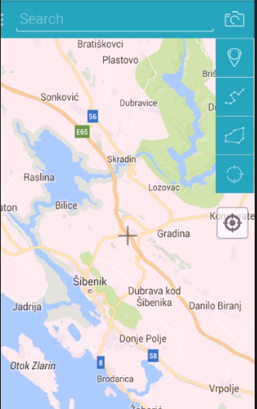
3 - To add a POI (Point of Interest) on the right top corner you have a Option Menu.

a) To add just a point choose this option:

b) To add a point with photo this option:

Add the point by “clicking” on the cross

Even if you use the first option later you can edit the point to add photos or change his position by just clicking on it.

Remember that the point will be added where the cross is positioned.

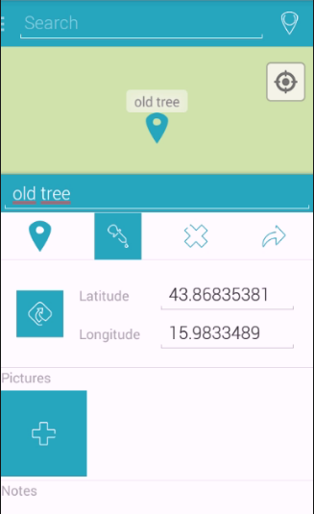

4 - Editing a point - Just click on it and change the name, add notes or add a photo.

After finishing your track and to be able to see it on Google Earth to contextualize it or to add more information you need to export it.

Open the “Left Menu” and click on the file (long click). This options will appear.
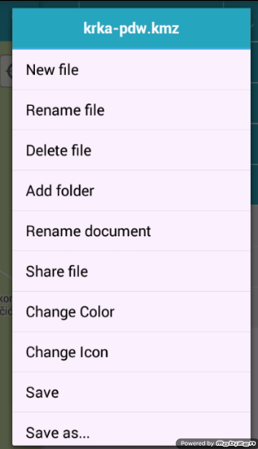

5 - Click on “Share file”. You can export it by mail, bluetooth or even send it to Google Drive.
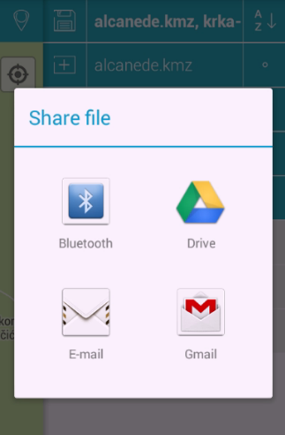

After have it on your computer open it with Google Earth and explore it with your students or ask them to add more info into the POI.

