App Instructions

ThingLink (Make your images come alive with private video, notes, or even music from YouTube)

How to use it:

1 - Signup (https://www.thinglink.com/) creating an account. Do not forget to register as teacher because this option allow you to manage classes inside ThingLink.

2 - You can access yours “thinglinks images” via web (https://www.thinglink.com/) but the best way to create the “thinglinks images” in outdoor activities is by using a mobile device (smartphone or tablet).

3 - As you already have this app installed: first login.

After it just start by creating a new “thinglink image”. Click on the + on the right top corner.

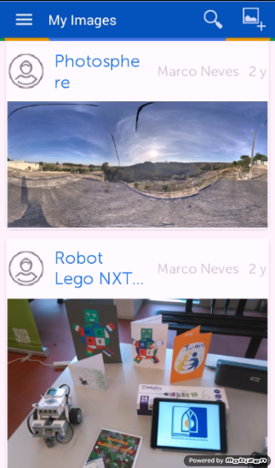

4 - First step is to choose an image that will be the background of the “thinglink image”.

You can either use an image already saved in your device or take a photo with your device.

5- Any were during the track choose an amazing landscape, a tree or any other place and take a photo. Could also take a photo with your team members.

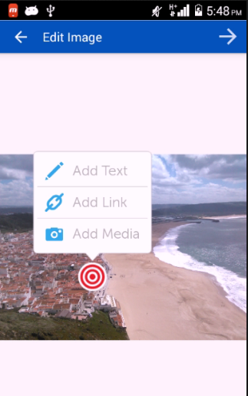

6- After that just add multimedia tags in your background image that could be text, another image or even vídeo.

Just click anywhere on the background image.

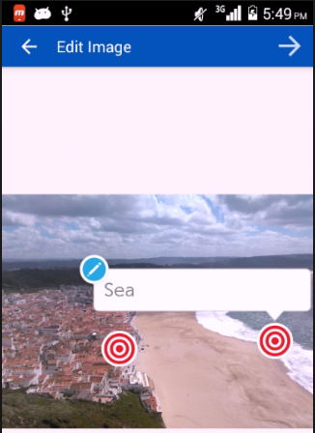
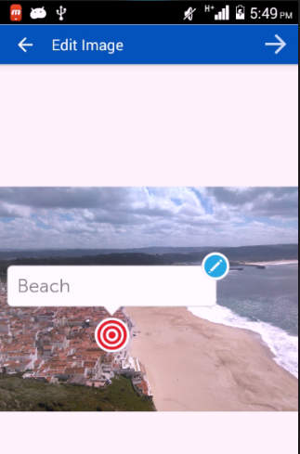

An example of a text point.

Add as many points as you wish.

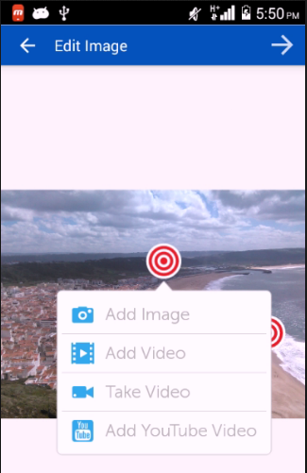

The “Add Media” possibilities (image, video…..).

7- When you finish add all the points you need to save the “thinglink image”. Just click on the right arrow on the right top corner.

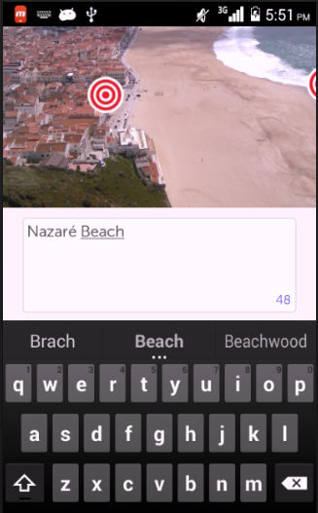

Give a name to your “thinglink image”. An that´s all. You just create a “thinglink image”.

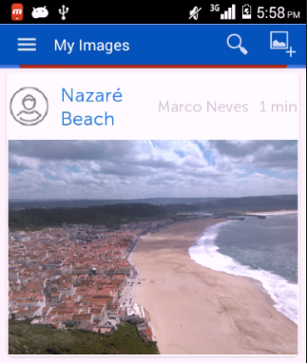

Now you can see the last “thinglink image” on yours “thinglink image” list.

After it you can share it so others can see it and explore it.

Just click on the “thinglink image” to open the share options.

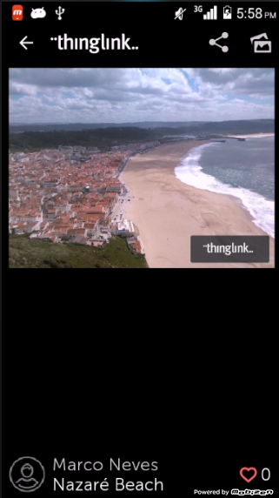

8- Click on the share button and share your “thinglink image” via Facebook, Twitter. etc..

Do not forget to share with us your “thinglink images”.

On Twitter use a hashtag: #<your hashtag>

Explore an example of an outdoor activity created during a workshop in Guimarães - Portugal:

https://www.thinglink.com/scene/587705703582400516

