Apps Instructions

Mapinr (An App to view and add points of interest in a Map and to georeference a path with pictures that can be seen and explored in Google Earth)

Download Android (only available for this type of devices)
https://play.google.com/store/apps/details?id=at.xylem.mapin

The main goal of this app is to record a track (by geo referencing it) and at the same time add/mark POIs (Point of Interest).

Imagine that you take your students in a field trip and along the way there are points that you consider relevant to study/observe.

Using this App you and your students are able to record the track, that you are following and at the same time when reach a point of interested add/mark it by adding text information or even photos.

During the track you could collect more information by using the device or even a pencil and piece of paper. Because after finishing the track you will able to export it and explore it in Google Earth.

Once in Google Earth or MYMaps you have the opportunity to use all the information provided by Google Earth/MYMaps and contextualize the track and enhance the POI (points) by adding more information that you collected.

How to use it:

The App have a right and left menu: to access it just slide your finger on to right or to the left.
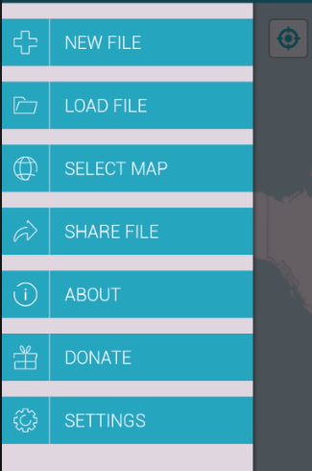

The “Right Menu” has the main functionalities of the App

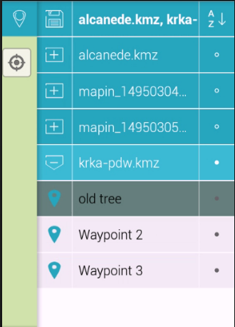

The “Left Menu” has the options to manage the different tracks and the points.

In the example the track krka_pdw.kmz has 3 points:
- old tree
- Waypoint 2
- Waypont 3

1- To start a new track just open the “Right Menu”

2 - Choose “New File” and name it.

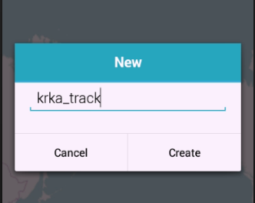

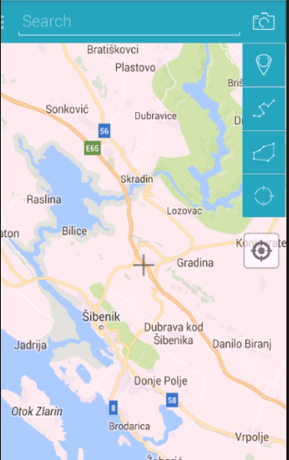
3 - To add a POI (Point of Interest) on the right top corner you have a Option Menu.

a) To add just a point choose this option:

b) To add a point with photo this option:

Add the point by “clicking” on the cross

Even if you use the first option later you can edit the point to add photos or change his position by just clicking on it.

Remember that the point will be added where the cross is positioned.

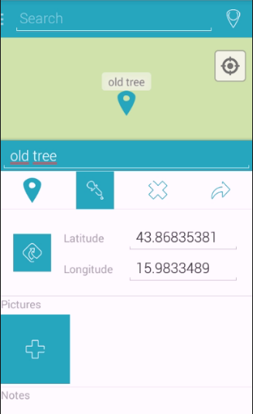

4 - Editing a point - Just click on it and change the name, add notes or add a photo.

After finishing your track and to be able to see it on Google Earth to contextualize it or to add more information you need to export it.
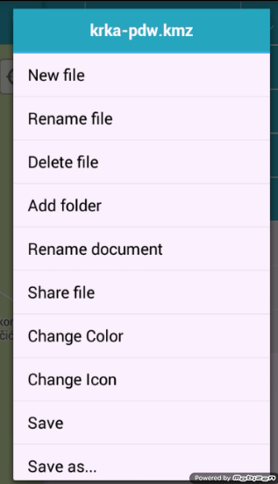

Open the “Left Menu” and click on the file (long click). These options will appear.

5 - Click on “Share file”. You can export it by mail, bluetooth or even send it to Google Drive.

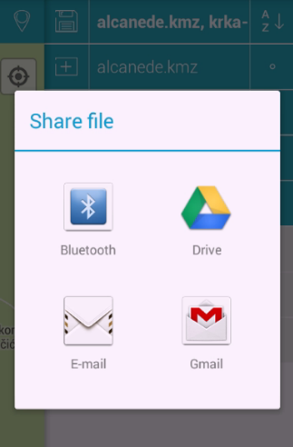

After having it on your computer open it with Google Earth and explore it with your students or ask them to add more info into the POIs and even create a Google Earth Tour about it.

